

**Cairo University**

**Faculty of Computers and Information**

**Information Technology Department**

**Farmer Guide**

Supervised by:

**Prof: Reda Abd-AL Wahab**

**Dr: Ghada Dahy**

*7th July*

*Fall 2024*

**Cairo University**

**Faculty of Computers and Information**

**Information Technology Department**

Prepared by:

|  |  |  |
| --- | --- | --- |
| **No.** | **Students’ Names** | **IDs** |
| 1 | Islam Abd-Alglil Mahmoud Elsayed | 20200079 |
| 2 | Abdelrahman Ahmed Hussien | 20200277 |
| 3 | Omar Mohammed Abde-Alrahman | 20200357 |
| 4 | Youssef Mahmoud Gomaa | 20200670 |
| 5 | Ahmed Mohamed Gomaa Abdelaziz | 20190065 |

**TABLE OF CONTENTS**

Page

LIST OF FIGURES i

LIST OF TABLES iii

ACKNOWLEDGEMENTS iv

ABSTRACT v

CHAPTER 1: Introduction 1

CHAPTER 2: Related Work 5

2.1 Plant Diseases Detection 5

2.2 Disease Percentage Module 5

2.3 Insect Sound Recognition 8

2.4 Soil Management and Crop Recommendation 8

CHAPTER 3: Proposed Model 9

3.1 Proposed System Model 9

3.2 Common Plant Disease Module 10

3.3 Real Plant Disease Module 11

3.4 Disease Percentage Module 12

3.5 Insect Sound Recognition Module 14

3.6 Soil Management Module 14

CHAPTER 4: Experimental Results 15

4.1 Datasets 15

4.2 Classification Results of Common Plant Diseases 19

4.3 Evaluation of Detection of Real Plant Diseases 19

4.4 Results of Diseases Percentage 20

4.5 Evaluation and Optimization of Insect and Sound 22

4.6 Processing and Evaluation for Soil Management 23

4.7 Website of the Proposed Model 25

CHAPTER 5: Conclusion 34

REFERENCES 35

**LIST OF FIGURES**

Page

Figure 1.1a example image of common plant diseases 1

Figure 1.1b example image of common plant diseases 1

Figure 1.2a example image of real plant diseases 2

Figure 1.2b example image of real plant diseases 2

Figure 1.3a example image of real plant diseases segmented 2

Figure 1.3b example image of real plant diseases segmented 2

Figure 1.4 segmentation model 3

Figure 2.1 Segmentation I/O 6

Figure 2.2 Plant Diseases Accuracy 7

Figure 2.3 Comparison of Results 7

Figure 2.4 Classification Results per Class for Proposed Method 7

Figure 2.5 Classification Results per Class for Proposed Method 8

Figure 3.1 System Diagram 9

Figure 3.2 Apple___Black_rot 11

Figure 3.3 Plant Diseased Area1 13

Figure 3.4 Plant Diseased Area2 13

Figure 4.1 Dataset Categories 15

Figure 4.2 Fruit Diseases 15

Figure 4.3 Fruit Diseases Images 15

Figure 4.4 Vegetables Diseases 15

Figure 4.5 Dataset Categories 16

Figure 4.6 Vegetables Disease 16

Figure 4.7 Fruit Diseases 16

Figure 4.8 Test Images 17

Figure 4.9 Number of Samples 17

i

Figure 4.10 Labels Contributions 18

Figure 4.11 Kernel Density Estimate (KDE) Plot of Features 18

Figure 4.12 Loss and Accuracy for Train, Validation Data 19

Figure 4.13 All Scores 19

Figure 4.14 Results of Diseases Percentage 1 20

Figure 4.15 Results of Diseases Percentage 2 21

Figure 4.16 Results of Diseases Percentage 3 21

Figure 4.17 Results of Diseases Percentage 4 21

Figure 4.18 Accuracy of Models using NPK with other factors x Accuracy of Models using NPK solely 24

Figure 4.19 Accuracy of Normalized NPK dataset 24

Figure 4.20 Home Page 25

Figure 4.21 Login Page 26

Figure 4.22 Registration Page 27

Figure 4.23 Service1 : Plant Disease Detection 29

Figure 4.24 Service2 : Plant Disease Segmentation 29

Figure 4.25 Service3 : Insect Sound Recognition 30

Figure 4.26 Service4 : Soil Nutrients Management 30

Figure 4.27 Edit Account 31

Figure 4.28 Show my Orders(table of the orders that the user made) 31

Figure 4.29 Show Incoming Orders 32

Figure 4.30 Show Accepted Orders 32

Figure 4.31 Show Inventory 32

Figure 4.32 Send Order Page 33

ii

**LIST OF TABLES**

Page

Table 4.1 Comparison between VGG19, ResNet50, MobileNetV2 20

Table 4.2 Diseases of Plants 22

iii

**ACKNOWLEDGEMENTS**

We would like to express our deepest gratitude to our committee chair, Professor Reda Abd-AL Wahab and Doctor Ghada Dahy, whose expertise, understanding, and patience added considerably to my graduate experience. His encouragement and support from the initial to the final level enabled me to develop an understanding of the subject. Without his invaluable guidance, persistent help, and insightful feedback, this project would not have been possible. We are also profoundly grateful to Dr. Ghada Dahy, whose continuous support and encouragement throughout this journey was immeasurable. Her expertise and dedication to the field have been inspiring, and her constructive feedback has been instrumental in the successful completion of this project.

We would like to extend my appreciation to the Faculty of Computers and Information at Cairo University for providing the necessary resources and a conducive learning environment. The technical support and facilities provided were indispensable for the completion of this project.

We are also thankful to the United States Department of Agriculture (USDA) for providing the datasets and resources that were critical for the research and development of our systems. The Bug Bytes sound library and other data sources played a significant role in our project's success.

Thank you all for your invaluable contributions to this project.

iv

**ABSTRACT**

Farmers suffer from many problems, such as the crop becoming infected with diseases or the spread of harmful insects, and sometimes the soil is not suitable for growing some crops in the first place. Our initiative provides farmers with comprehensive support to enhance crop health, minimize pest damage, and optimize crop choices based on soil conditions and environmental factors.

Challenges have emerged during the development of the system. One of the obstacles was the limited availability of some images of diseases for certain types of vegetables and fruits. In some types of plants, pictures are provided only in their healthy state. One major hurdle has been the limited availability of a diverse and comprehensive dataset of insect sounds. To address this constraint, data augmentation techniques have been employed to artificially expand the dataset. Ensuring accurate data collection for NPK levels and environmental factors, as well as addressing variations in soil composition across regions was a challenge.

Plant Disease Detection and Segmentation Proposed Model; A deep learning-based(CNN) plant disease detection model using MobileNetV2 and transfer learning to classify plant health and diseases, supplemented by data augmentation for increased training data diversity. The model also includes image segmentation techniques to calculate the percentage of diseased areas, guiding optimal fertilizer application.

Insect Sound Recognition Model: This study leverages robust machine learning techniques developed for image classification and applies them to the sound recognition problem. By converting raw audio data into spectrogram representations, the study explores two approaches using deep convolutional neural networks (CNNs).

Soil Management and Crop Recommendation Model; The model leverages soil nutrient analysis and environmental data, employing machine learning algorithms to provide precise crop recommendations. This approach ensures optimal crop selection and sustainable soil utilization, enhancing agricultural productivity.

Results: We tried many experiments on several Convolution layers and several kernels to get the best performance for this model. The maximum score that CNN model gave us 98.12%. Inception V3's 95% accuracy. ResNet's 91% accuracy, while slightly lower, still reflects strong performance and the advantage of deeper network architecture. MobileNet's 89% accuracy. Using (NPK) with temperature, humidity, pH, and rainfall dataset, the best ML algorithm was, the best Machine learning algorithm was (DT) at a (98.63%) accuracy and using (NPK) solely without other factors (KNN) at a (65.45%) accuracy and after Normalization gave (79.90%) with (SVM).

v

**CHAPTER 1: Introduction**

**Main Problem**: Our "Farmer Guide" project offers three essential services to farmers: crop protection through image detection of plant diseases, crop guarding via sound detection of insects around plants, and crop recommendation using sensors and machine learning. By leveraging these advanced technologies, our initiative provides farmers with comprehensive support to enhance crop health, minimize pest damage, and optimize crop choices based on soil conditions and environmental factors. Through the integration of image processing, sound analysis, and machine learning, our platform empowers farmers with actionable insights for proactive crop management, ultimately promoting agricultural sustainability and productivity.

**Main Idea**: The image detection system identifies plant diseases of vegetables and fruits based on images of their leaves, and then determines whether the plant is healthy or whether there is a disease. The disease is determined, and this is done through approaches based on deep learning because it uses statistical machine learning and an image processing algorithm. The sound-based bug detection system aims to categorize insects into three primary classes: those that pose threats to human health, those that consume plants, and those that directly affect the health of plants by transmitting diseases. Leveraging advancements in machine learning and signal processing, this innovative approach provides an additional layer of precision to the overall plant health monitoring system. The significance of NPK (Nitrogen, Phosphorus, Potassium) in soil lies in their pivotal roles as essential nutrients for plant growth and development. Nitrogen is crucial for leafy green growth and overall plant vigor, phosphorus supports root development, flowering, and fruiting, while potassium contributes to disease resistance, water uptake, and overall plant health. The balanced presence of these nutrients is fundamental for crop productivity and quality. This system acknowledges the critical importance of NPK in optimizing agricultural practices. By assessing NPK levels alongside environmental factors (temperature, humidity, pH, and rainfall), which are provided electively, the system ensures precise recommendations, facilitating farmers in maintaining soil fertility, minimizing nutrient deficiencies, maximizing crop yields sustainably, and most importantly identifying potential diseases affecting crops.

Common Plant Diseases Old Images(from Kaggle):

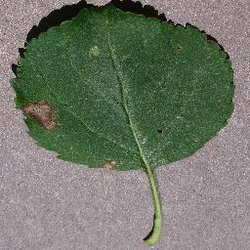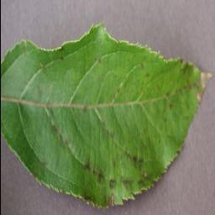

Figure 1.1a

Figure 1.1b

Plant Diseases New Images(from farmers):

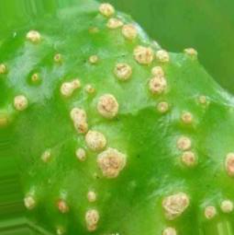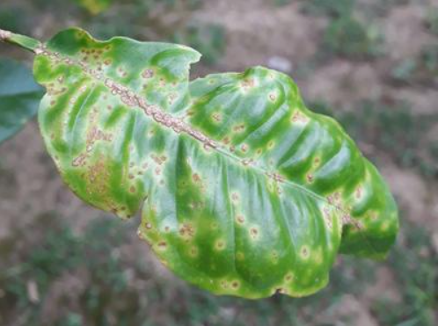

Figure 1.2b

Figure 1.2a

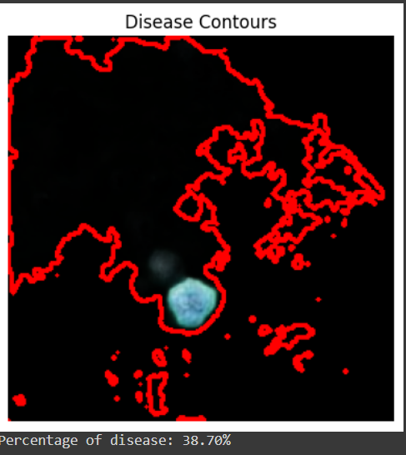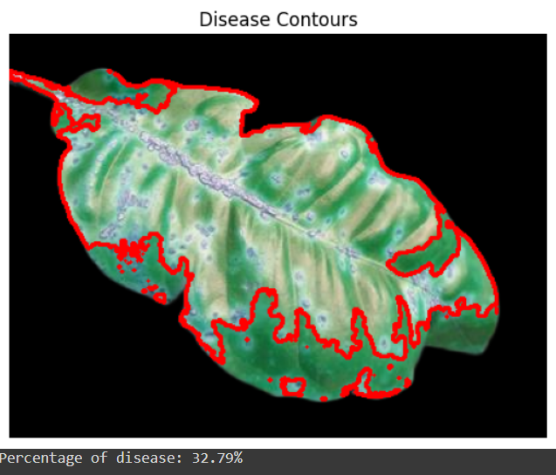Plant Diseases New Images(after Segmentation):

Figure 1.3b

Figure 1.3a

Segmentation Model:

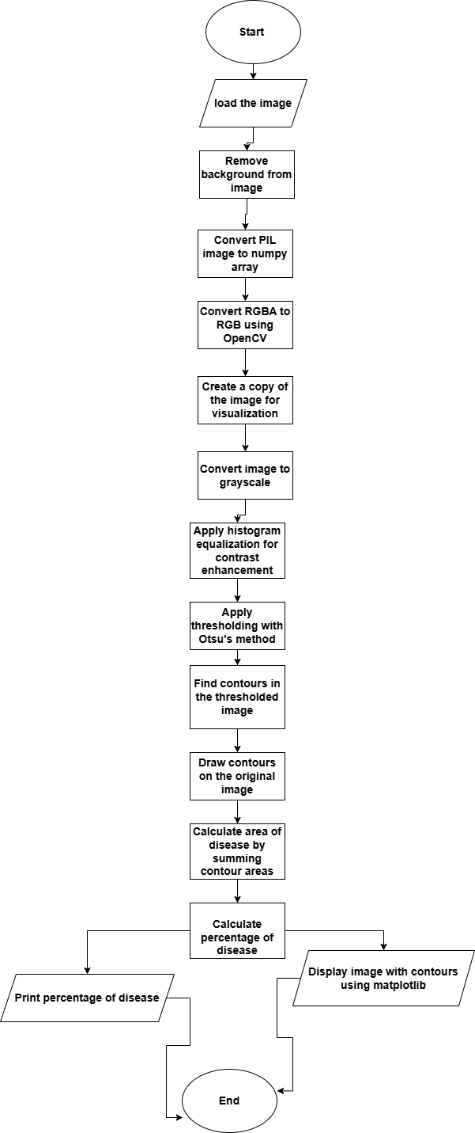

Figure 1.4 Segmentation Model

Detects diseases with background removal and contrast enhancement(image path), which processes an image to detect and quantify disease on a leaf. Initially, the image is loaded, and its background is removed. The modified image is then converted from a PIL format to a NumPy array for OpenCV processing, followed by a conversion from RGBA to RGB. A copy of this image is created for visualization purposes. The image is then converted to grayscale, and histogram equalization is applied to enhance contrast. Using Otsu's method, the grayscale image undergoes thresholding to create a binary image, from which contours are extracted. These contours, representing diseased areas, are drawn onto the original image copy. The function calculates the disease area by summing the areas of the contours and determines the total leaf area from the image dimensions. The percentage of diseased area is then calculated and displayed along with the contoured image using matplotlib.

Sound Detection Model: The proposed sound-based bug detection system uses machine learning and signal processing to classify insects into three categories: those harmful to human health, plant-consuming insects, and disease-transmitting insects. This novel approach enhances the precision of plant health monitoring.

Soil Management and Crop Recommendation Model; NPK (Nitrogen, Phosphorus, Potassium) are essential nutrients for plant growth, supporting leaf development, root growth, and disease resistance. By assessing NPK levels and environmental factors, the system provides precise recommendations to maintain soil fertility, maximize crop yields, and identify potential crop diseases.

**Main Contribution Results/Accuracies**; We tried many experiments on several Convolution layers and several kernels to get the best performance for this model. The maximum score that CNN model gave us 98.12% and segmentation part gives the contours which pixels help to find the diseased area of the plant. The comparative results of the three models highlight the strengths and trade-offs associated with each architecture. Inception V3's 95% accuracy signifies its advanced feature extraction capabilities and suitability for high-precision applications. ResNet's 91% accuracy, while slightly lower, still reflects strong performance and the advantage of deeper network architecture. MobileNet's 89% accuracy, though the lowest among the three, demonstrates its potential for deployment in scenarios where efficiency and low computational overhead are critical. Using (NPK) with temperature, humidity, pH, and rainfall dataset, the best ML algorithm was, the best Machine learning algorithm was (DT) at a (98.63%) accuracy and using (NPK) solely without other factors (KNN) at a (65.45%) accuracy and after Normalization gave (79.90%) with (SVM).

**Summary**:

1. List of Figures
2. List of Tables
3. Acknowledgements
4. Abstract: about the topic of the document.
5. Introduction: main problem, main idea, intro to each subsystem, main contributions
6. Related Work: brief description about past papers on this topic.
7. Proposed Model: whole system diagram and description.
8. Experimental Results: dataset, its description, old and new results, website screenshots
9. Conclusion: about the final resolve of our efforts in this research
10. References: resources of datasets and papers and techniques.

**CHAPTER 2: Related Work**

2.1 **Plant Diseases Detection**

Shiroop Madiwalar and Medha Wyawahare analyzed different image processing approaches for plant disease detection in their research.

Authors analyzed the color and texture features for the detection of plant disease. They have experimented their algorithms on the dataset of 110 RGB images. The features extracted for classification were mean and standard deviation of RGB and YCbCr channels, grey level cooccurrence matrix (GLCM) features, the mean and standard deviation of the image convolved with Gabor filter. Support vector machine classifier was used for classification. Authors concluded that GCLM features are effective to detect normal leaves. Whereas color features and Gabor filter features are considered as best for detecting anthracnose affected leaves and leaf spot respectively. They have achieved highest accuracy of 83.34% using all the extracted features.Garima Shrestha et Al. deployed the convolutional neural network to detect the plant disease. [3]

Authors have successfully classified 12 plant diseases with 88.80% accuracy. The dataset of 3000 high resolution RGB images was used for experimentation. The network has 3 blocks of convolution and pooling layers. This makes the network computationally expensive. Also, the F1 score of the model is 0.12 which is very low because of a higher number of false negative predictions.

2.2 **Disease Percentage Module**

Vijai Singha,*, A.K. Misrab aComputer Science Department, IMS Engineering College, Ghaziabad, UP, India bComputer Science & Engg. Department, MNNIT Allahabad, UP, India.

2.2.1: Proposed Methodology: Digital cameras or similar devices are used to take images of leafs of different types, and then those are used to identify the affected area in leafs. Then different types of image processing techniques are applied on them, to process those images, to get different and useful features needed for the purpose of analyzing later. The algorithm written below illustrates the step-by-step approach for the proposed image recognition and segmentation processes.[4]

* Image acquisition is the very first step that requires capturing an image with the help of a digital camera.
* Preprocessing of input image to improve the quality of image and to remove the undesired distortion from the image. Clipping of the leaf image is performed to get the interested image region and then image smoothing is done using the smoothing filter. To increase the contrast Image enhancement is also done.
* Mostly green colored pixels, in this step, are masked. In this, we computed a threshold value that is used for these pixels. Then in the following way mostly green pixels are masked: if pixel intensity of the green com ponent is less than the pre-computed threshold value, then zero value is assigned to the red, green and blue components of this pixel.
* In the infected clusters, inside the boundaries, remove the masked cells.
* Obtain useful segments to classify the leaf diseases. Segment the components using genetic algorithm.
* Computing the features using color co-occurrence methodology for feature extraction the method used is color co-occurrence method. It is the methodology in which both the texture and color of an image are considered, to come to the unique features, which shows that image. Over the traditional gray-scale representation, in the visi ble light spectrum, the use of color image features provides an additional feature for image characteristic. There are three major mathematical processes in the color co-occurrence method. First, conversion of the RGB images of leaves is done into HIS color space representation. After completion of this process, to generate a color co-occurrence matrix, each pixel map is used, which results in three color co-occurrence matrices, one for each of 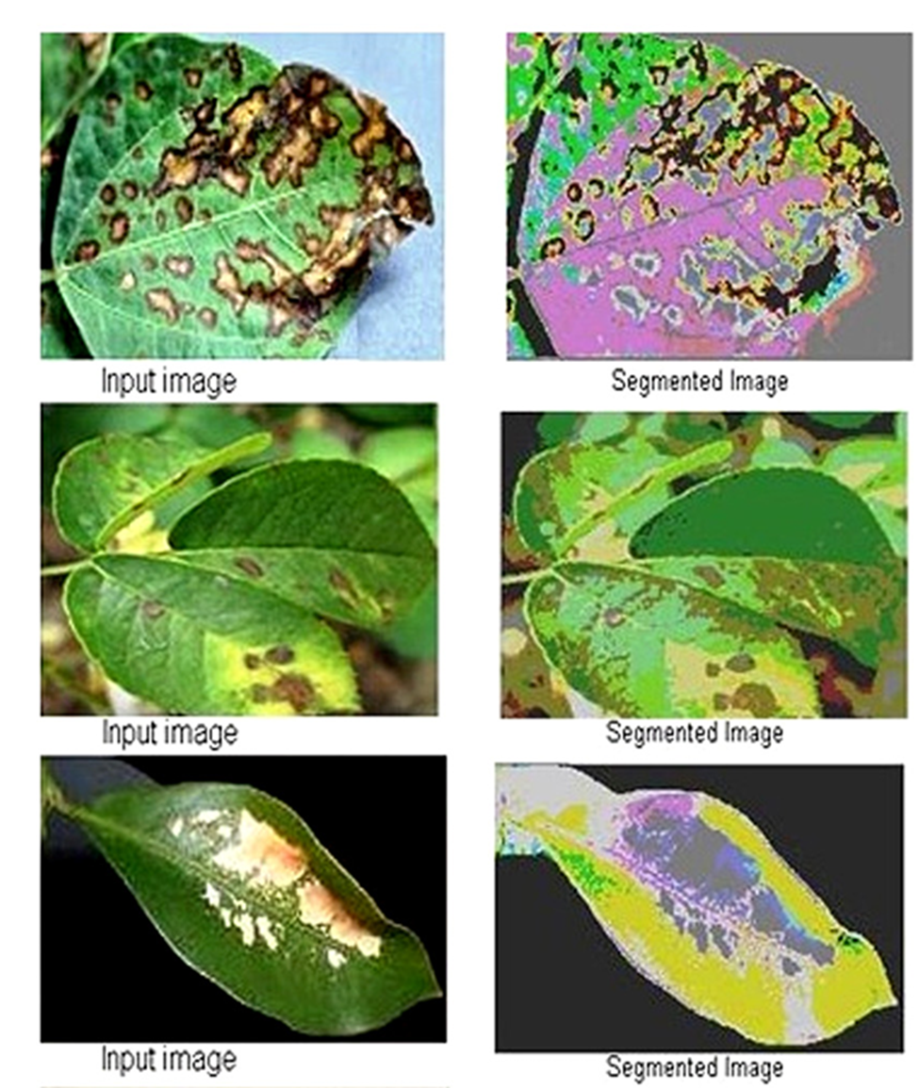H, S, I.

Figure 2.1: Segmentation I/O

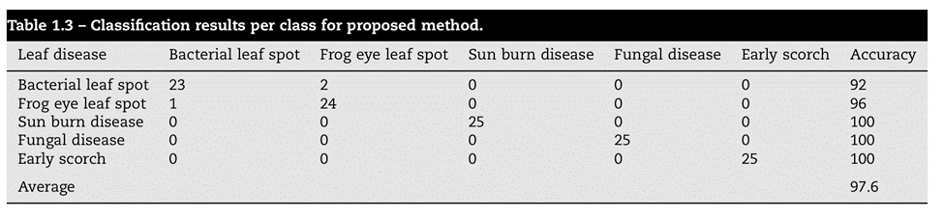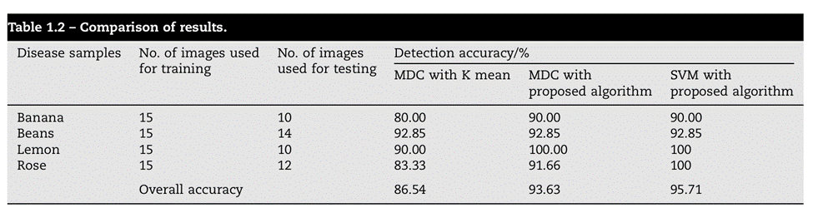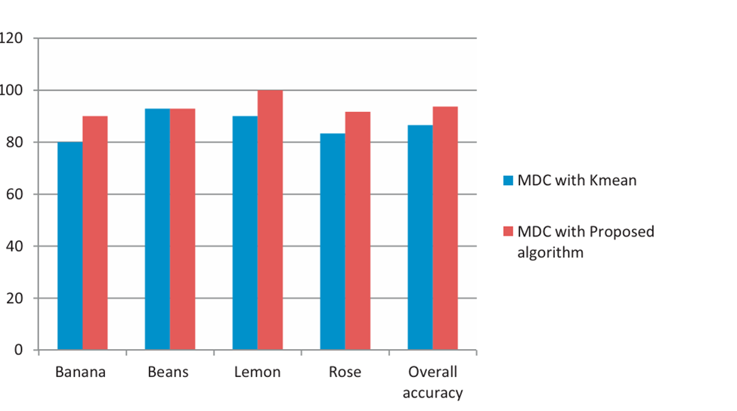

Figure 2.4: Classification Results per Class for Proposed Method

Figure2.2: Plant Diseases Accuracy

Figure 2.3: Comparison of Results

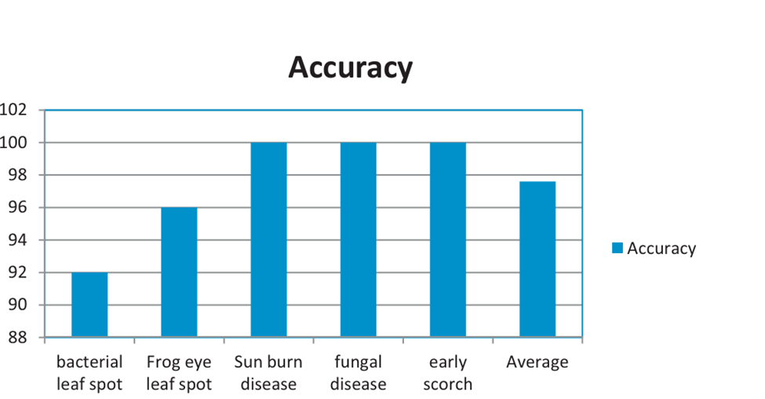

Figure 2.5: Classification Results per Class for Proposed Method

2.3 **Insect Sound Recognition**

Automatic sound recognition has become a significant area of research due to its wide range of applications, including video/audio content labeling and real-time sound detection for robotics. While image classification has been extensively studied, sound identification remains less mature. This study leverages robust machine learning techniques developed for image classification and applies them to the sound recognition problem. By converting raw audio data into spectrogram representations, the study explores two approaches using deep convolutional neural networks (CNNs): a self-developed CNN architecture and transfer learning with the pre-trained VGG19 network. The self-developed architecture achieves a label-weighted label-ranking average precision (LWLARP) score of 0.813 and a top-5 accuracy of 88.9% when predicting 80 sound classes [5][6][7].

2.4 **Soil Management and Crop Recommendation**

In a previous study, researchers developed a system utilizing soil NPK sensors to read soil nutrient data. They implemented the K-Nearest Neighbors (KNN) classifier to analyze this data and make predictions regarding optimal crop choices. By integrating sensor technology and Arduino board with the KNN algorithm, the system achieved high accuracy (99.67%) displayed using a web application developed using python-based web development framework, flask. This approach highlights the potential of sensor-based technologies in precision agriculture, facilitating informed decision-making for farmers and promoting sustainable crop management practices.

**CHAPTER 3: Proposed Model**

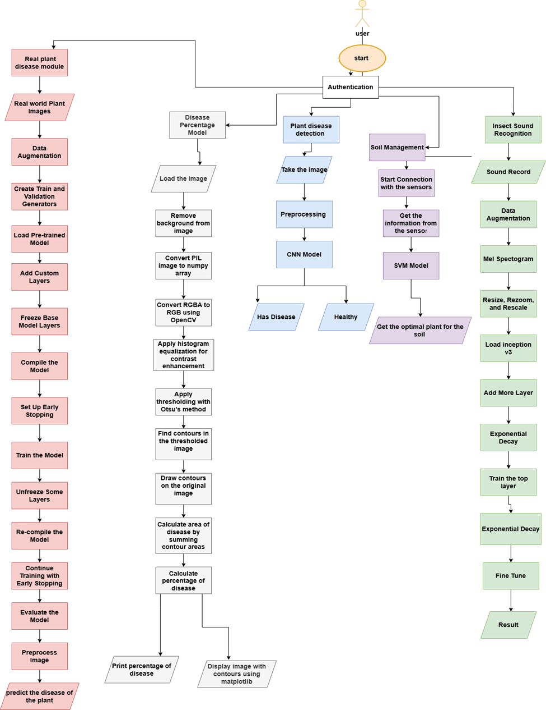3.1 **Proposed System Model**

Figure 3.1: System Diagram

Farmers suffer from many problems, such as the crop becoming infected with diseases or the spread of harmful insects, and sometimes the soil is not suitable for growing some crops in the first place. Working on these problems requires a lot of labor, money, and time, which may be too late to solve the problem. By leveraging these advanced technologies, our initiative provides farmers with comprehensive support to enhance crop health, minimize pest damage, and optimize crop choices based on soil conditions and environmental factors. So, Developing Farmer Guide application. Which is provide solution to easily detect plant diseases through 5 approaches :

* Real plant disease module.
* Disease percentage module.
* Plant disease detection.
* Insect Sounds detection system.
* Soil management and crop recommendation.

This project helps the farmer in many tasks such as saving time, effort, labor, and rationalizing the use of fertilizers in solving agriculture and crops problems.

The image detection system identifies plant diseases of vegetables and fruits based on images of their leaves, and then determines whether the plant is healthy or whether there is a disease. The disease is determined, and this is done through approaches based on deep learning because it uses statistical machine learning and an image processing algorithm.

Real plant disease module this subsystem works on real data samples to determine whether the plant is healthy or has a disease and identify the class of the disease.

Disease percentage subsystem detect disease with background removal and contrast enhancement which processes an image to detect and quantify disease on a leaf and evaluate the percentage of the disease Determine the incidence of the disease to know the number of fertilizers and pesticides needed to treat the disease.

Insect sound recognition in this approach we developed a classification model which detects the insects. Which makes the farmers can take timely and targeted actions to mitigate the impact of insect infestations. The system contributes to sustainable farming practices by minimizing the need for broad-spectrum pesticides, thus promoting environmentally friendly pest management.

Soil management and crop recommendation the proposed system aims to develop a crop recommendation system using information from NPK (Nitrogen, phosphorus, potassium) sensor and other sensors for temperature, humidity(moisture is more accurate),pH, and a report to know the ratio of rainfall at the area of the soil in our system, to find out more about the nutritional composition of the soil.

Details of how each subsystem works:

3.2 **Common Plant Disease Module**

Image Detection for plants and crops.

3.2.1 take images from mobile camera.

3.2.2 do preprocessing for this image to enhance the image.

3.3.3 feed enhanced image to (CNN) model to detect if that plant is healthy or unhealthy and what is the disease that plant has.

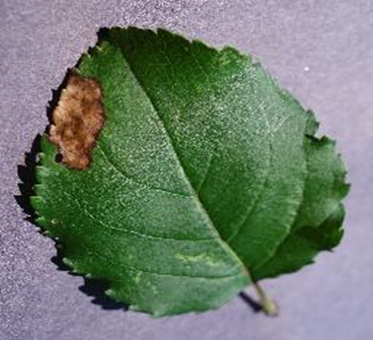

Figure 3.2: Apple___Black_rot

3.3 **Real Plant Disease Module**

The proposed model is a convolutional neural network (CNN) for image classification, leveraging transfer learning with the MobileNetV2 architecture. The code involves several key steps: data augmentation, model creation, training, fine-tuning, evaluation, and prediction. Let's break down each part of the code in detail.

3.3.1: Data augmentation is a technique used to artificially increase the size of a training dataset by creating modified versions of images in the dataset. This helps improve the model's generalization ability. The data augmentation accomplishes these tasks

* Normalizes the image pixel values to the range [0, 1].
* Randomly rotates images by up to 40 degrees.
* Randomly shifts images horizontally by up to 20% of the width.1.2
* Randomly shifts images vertically by up to 20% of the height.
* Applies random shear transformations.
* Applies random zoom transformations.
* Randomly flips images horizontally.
* Specifies how to fill newly created pixels, when the image is rotated or shifted.

3.3.2: Data Generators: Data generators are used to load images from directories, resize images, specify Number of images to be yielded from the generator per batch, indicates that the labels are categorical .and apply data augmentation in real-time during training.

3.3.3: Using a pre-trained MobileNetV2 model as the base, additional layers are added for the specific classification task.

3.3.4: Model Training with Early Stopping: Training the model with early stopping to prevent overfitting.

3.3.5: Fine-Tuning the Model: Unfreezing the last 10 layers of the base model and fine-tuning the entire model with a lower learning rate.

3.3.6: Model Evaluation: Evaluating the model's performance on training and validation data.

3.3.7: Image Preprocessing and Prediction: Preprocessing a single image and making a prediction using the trained model.

3.4 **Disease Percentage Module**

This subsystem performs disease detection on a leaf image by first removing the background, enhancing the image contrast, and then applying thresholding to identify diseased areas. Contours of these areas are detected and drawn on the image for visualization. The area of the diseased regions is quantified and expressed as a percentage of the total leaf area, providing a measure of the extent of the disease.

This model works as shown:

3.4.1 Load and Remove Background:

* The image is loaded using the PIL library.
* The background is removed using a function remove(), which isolates the leaf from the background.

3.4.2 Convert to OpenCV Format:

* The image without the background is converted from PIL format to a NumPy array.
* The image is then converted to RGB format using OpenCV.

3.4.3 Create a Copy for Visualization: A copy of the image is made for later visualization purposes.

3.4.4 Convert to Grayscale: The image is converted to grayscale, which is necessary for further image processing steps like contrast enhancement and thresholding.

3.4.5 Contrast Enhancement: Histogram equalization is applied to enhance the contrast of the grayscale image, making disease spots more distinguishable.

3.4.6 Thresholding: A binary threshold is applied to the equalized image using Otsu's method, which automatically determines the best threshold value. This step converts the image to a binary format where the disease areas are highlighted.

3.4.7 Find Contours: Contours are detected in the binary image. Contours are the boundaries of the disease spots.

3.4.8 Draw Contours on Original Image: The detected contours are drawn on the original image in red for visualization.

3.4.9 Calculate Disease Area: The area of the disease is calculated by summing up the areas of all detected contours.

3.4.10 Calculate Total Leaf Area: The total area of the leaf is calculated from the dimensions of the image.

3.4.11 Calculate Percentage of Disease: The percentage of the leaves affected by disease is calculated.

3.4.12 Display the Image with Contours: The image with the disease contours is displayed using matplotlib.

3.4.13 Print the Percentage of Disease: the percentage and the segmentation are shown as:

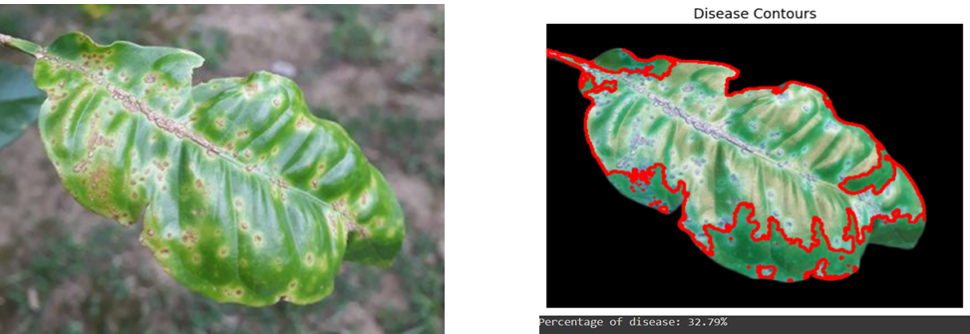

Figure 3.3: Plant Diseased Area1

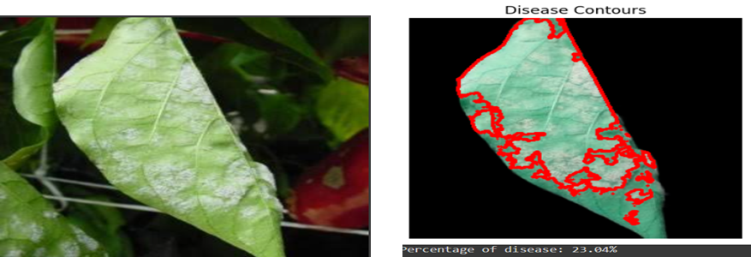3.5 **Insect Sound Recognition Module**

Figure 3.4: Plant Diseased Area2

3.5.1 record audio with sensitive mics.

3.5.2 get Mel spectrogram for the wav files.

3.5.3 get into (ResNet) model.

3.5.4 classify wav files according to 3 classes.

3.6 **Soil Management Module**

For soil condition for the target crops. This serves as the initial stage where soil-related data collection and analysis occur.

3.6.1: Connecting with Sensors: establish connections with soil sensors to retrieve real-time data on soil nutrient levels (NPK) and other relevant factors.

3.6.2: Retrieve Information from Sensors: Once connected, collect information from the sensors, including soil NPK levels, temperature, humidity/moisture, pH, rainfall ratio.

3.6.3: Classification Model: The collected data is then fed into a classification model, such as Support Vector Machine (SVM), to analyze the soil characteristics and make predictions.

3.6.4: Optimal Plant Recommendation: Based on the output of the classification model, the system determines the optimal plant or crop type suited for the specific soil conditions, to make it healthy and survive until harvest.

**CHAPTER 4: Experimental Results**

4.1 **Datasets**

4.1.1: Image Detection System:

4.1.1.1: Real Plant Disease Detection: The dataset is collected from real world samples, which contain fruit and vegetables images. Dataset components:[1]

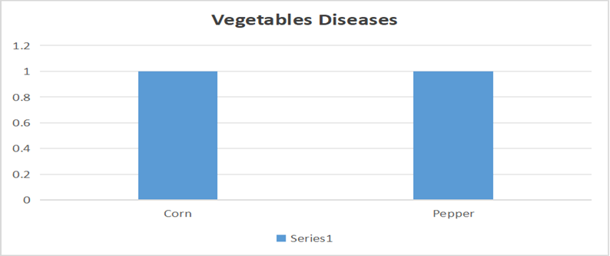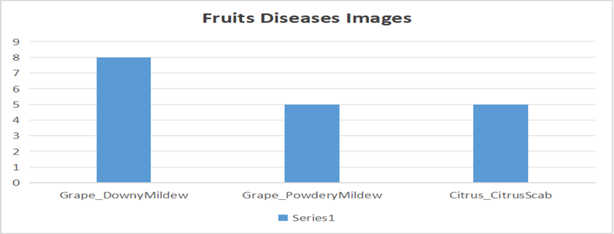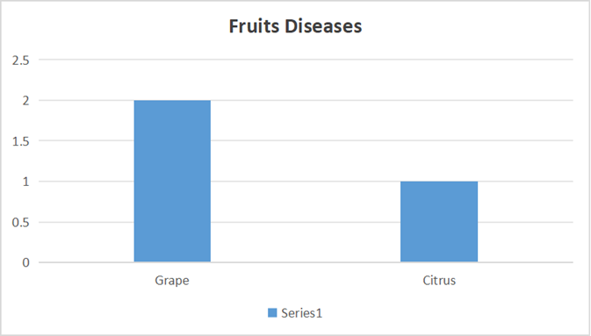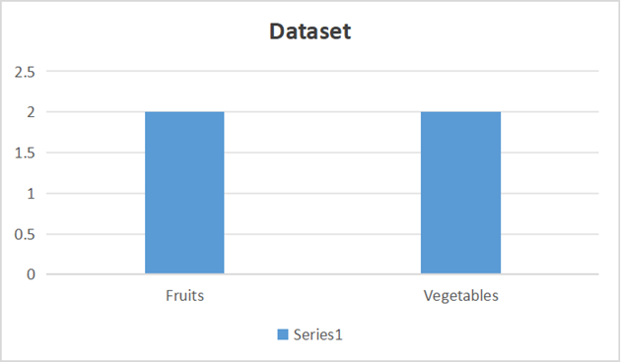

Figure 4.1: Dataset Categories

Figure 4.4: Vegetables Diseases

Figure 4.3: Fruit Diseases Images

Figure 4.2: Fruit Diseases

4.1.1.2: Plant Disease Detection: For this project we have used a public dataset for plant leaf disease detection called New Plant Diseases on Kaggle accessible via the provided link: new planet disease.[2]. The dataset consists of 87000 RGB images of healthy and unhealthy plant leaves having 38 classes. The total dataset is divided into 80/20 ratio of training and validation set preserving the directory structure. A new directory containing 33 test images is created later for prediction purposes. Dataset Components:

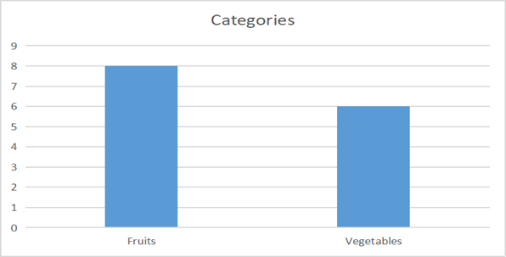

Figure 4.5: Dataset Categories

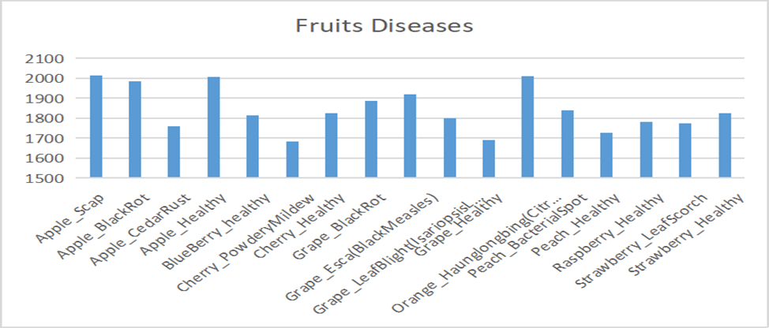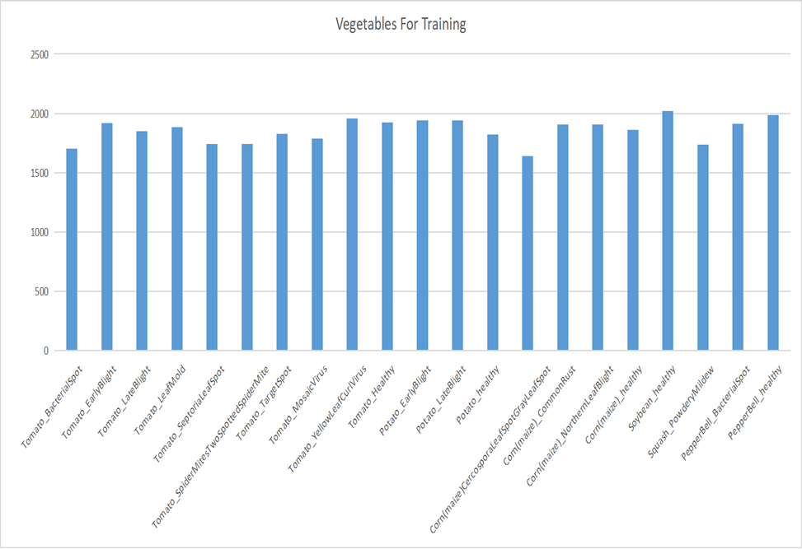

Figure 4.7: Fruits Diseases

Figure 4.6: Vegetables Diseases

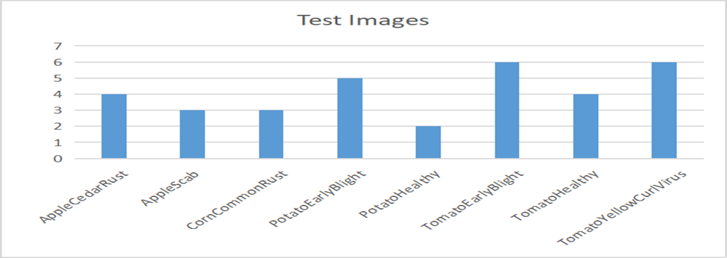

Figure 4.8: Test Images

4.1.2: Sound Recognition System:

The dataset obtained from the United States Department of Agriculture (USDA), accessible via the provided link: Bug Bytes sound library: stored product insect pest sounds (usda.gov). The dataset comprises 69 WAV samples, with each sample representing either an individual insect or multiple samples capturing the same insect under varying conditions such as different ages or different fruit types, The dataset is organized into three distinct classes. The first class comprises bugs that pose a threat to human health. The second class encompasses bugs that have an impact on plant health. Lastly, the third class consists of bugs that feed on plants.

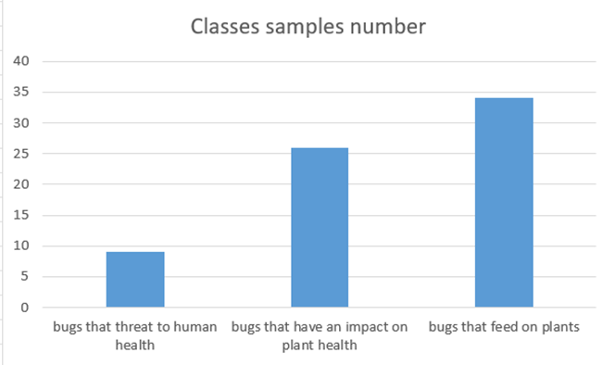

Figure 4.9: Number of Samples

4.1.3: Soil Management System:

The dataset comprises soil samples collected from various agricultural regions, encompassing measurements of nitrogen (N), phosphorus (P), potassium (K), as well as environmental factors including temperature, humidity, pH, and rainfall.[14]

The crops used for training our models represent a wide range (22) of crops commonly cultivated in agricultural practices. Each crop label corresponds to a specific type of crop, such as rice, maize, chickpea, kidney beans, etc. These labels serve as the target variables for our classification tasks, guiding our system in recommending the most suitable crops based on soil nutrient levels and environmental factors. They all contribute by the same percentage (100) of data rows in this practice.

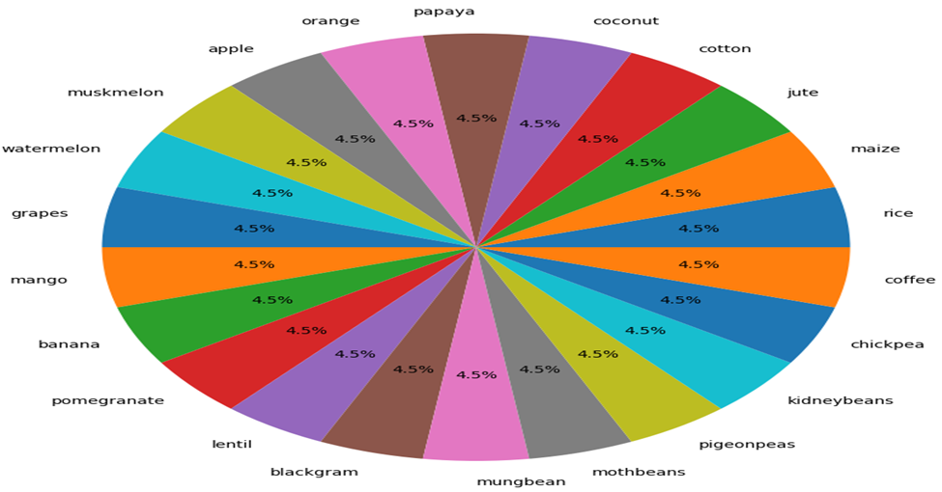

Figure 4.10: Labels Contributions

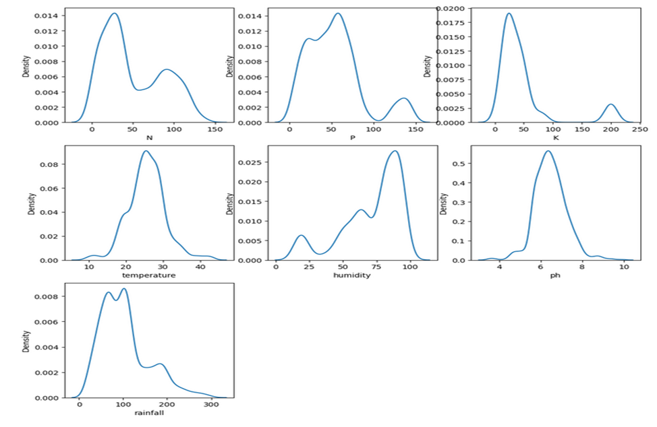

Figure 4.11: Kernel Density Estimate (KDE) Plot of Features

4.2 **Classification Results of Common Plant Diseases**

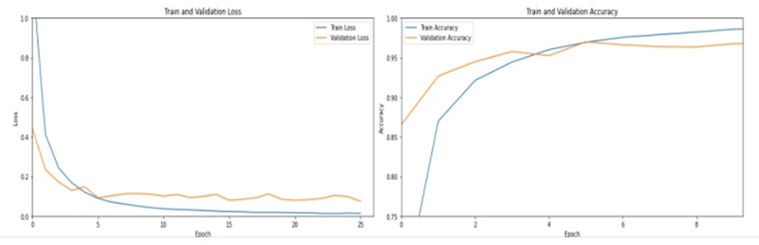We tried many experiments on several Convolution layers and several kernels to get the best performance for this model. The maximum score we got when we used six convolution layers with kernel size (3*3) and filter number 32, 64 and 128, three max-pooling layers with. The maximum score that we got is 98.12%.

Figure 4.12: Loss and Accuracy for Train, Validation Data

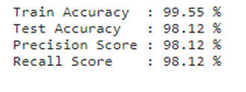

Figure 4.13: All Scores

4.3 **Evaluation of Detection of Real Plant Diseases**

We perform image classification using a deep learning model. It begins with data augmentation to increase the diversity of training images through various transformations such as rotation, scaling, and flipping. A pre-trained MobileNetV2 model is loaded, and custom layers are added for the specific classification task. The base model layers are initially frozen to leverage the pre-trained features, and the model is compiled with the Adam optimizer and categorical cross-entropy loss. Early stopping is implemented to prevent overfitting. The model is trained on the augmented dataset, then some layers of the base model are unfrozen for fine-tuning with a lower learning rate. The model is further trained, and a function is defined to evaluate its performance on training and validation data. Another function preprocesses input images to match the model's expected format, and a final function predicts the class of a given image. An example demonstrates using the model to predict the class of a specific image, with the predicted label printed as output, we have tried more than one model such as MobileNetV2, VGG19, and ResNet50. But MobileNetV2 achieved the highest accuracy.

The comparison between models as follow:

|  |  |  |  |
| --- | --- | --- | --- |
| **The Model** | * **VGG19** | * **ResNet50** | * **MobileNetV2** |
| **Training accuracy** | * **94.93%** | * **44.20%** | * **97.83%** |
| **Validation accuracy** | * **87.50%** | * **25%** | * **87.50%** |
| **Training loss** | * **0.1404** | * **1.4644** | * **0.0574** |
| **Validation loss** | * **0.2524** | * **1.6183** | * **0.4583** |

Table 4.1: Comparison between VGG19, ResNet50, MobileNetV2

4.4 **Results of Diseases Percentage**

This model processes a leaf image to detect and quantify diseased areas. It begins by loading the image and removing the background to isolate the leaf. The image is then converted to an OpenCV-compatible format and copied for visualization purposes. The leaf image is converted to grayscale, and histogram equalization is applied to enhance contrast. Otsu's thresholding is used to convert the enhanced image into a binary image, highlighting diseased regions. Contours of these regions are detected and drawn on the original image. The area of the diseased regions is calculated and compared to the total leaf area to determine the percentage of disease, which is then displayed along with the image marked with disease contours.

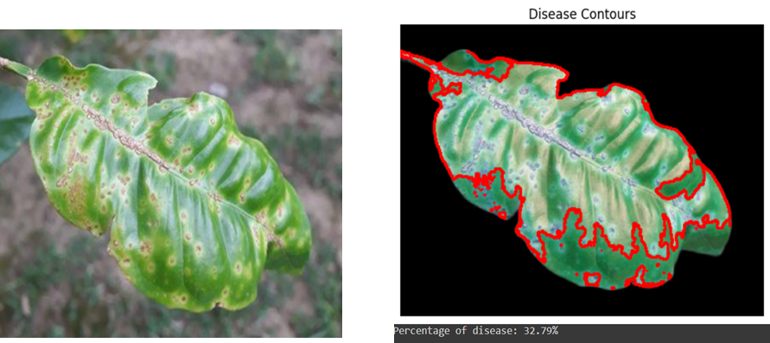There are some samples of images in segmentation model:

Figure 4.14: The percentage of disease: 32.79%

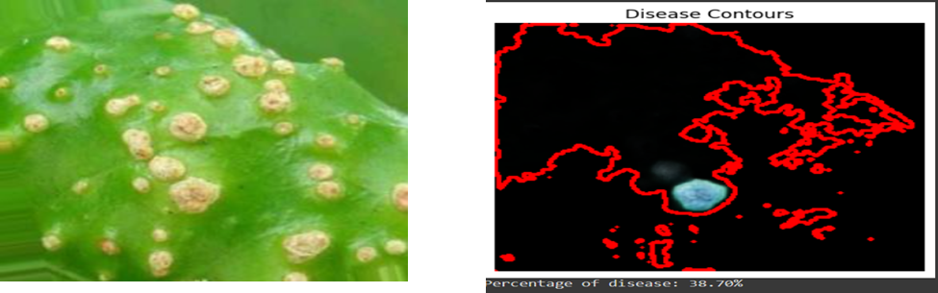

Figure 4.15: The percentage of disease: 38.70%

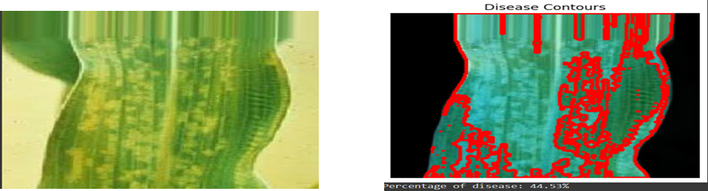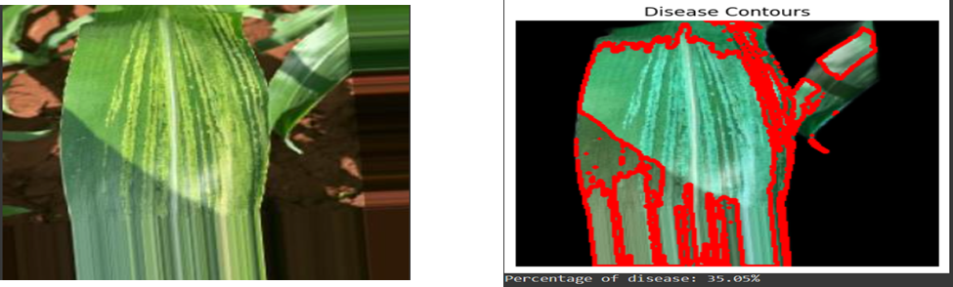

Figure 4.16: The percentage of disease: 44.53%

Figure 4.17: The percentage of disease: 35.05%.

The Diseases of Plants:

|  |  |  |  |  |  |
| --- | --- | --- | --- | --- | --- |
| The disease | Citrus_CitrusScab | Corn_DownyMildew | Grape_DownyMildew | Grape_PowderyMildew | Pepper  Powdery  Mildew |
| Sample#1 |  |  |  |  |  |
| Sample#2 |  |  |  |  |  |

Table 4.2: Diseases of Plants

4.5 **Evaluation and Optimization of Insect and Sound**

In our project on plant disease detection, we evaluated the performance of three state-of-the-art convolutional neural network (CNN) architectures: ResNet, MobileNet, and Inception V3. Our goal was to determine the most effective model for accurately identifying various plant diseases from image data. Additionally, we also tested a Support Vector Machine (SVM) classifier, which achieved an accuracy of 83%. The results of our experiments are summarized below.

SVM Performance; The SVM classifier, while not a deep learning model, provided a baseline accuracy of 83%. This traditional machine learning approach demonstrated its capability in handling image data, but its performance was lower compared to the CNN architectures. SVM's simpler model and lower computational requirements may still be beneficial in certain contexts where deep learning resources are limited.

ResNet Performance; ResNet, known for its deep residual learning capabilities, achieved an impressive accuracy of 91% in our experiments. The architecture's ability to mitigate the vanishing gradient problem through its use of residual blocks proved beneficial in learning complex patterns from the dataset. This high accuracy demonstrates ResNet's robustness and effectiveness in handling large-scale image classification tasks, making it a strong candidate for deployment in real-world plant disease detection systems.

MobileNet Performance; MobileNet, designed for mobile and embedded vision applications, attained an accuracy of 89%. While slightly lower than ResNet, MobileNet's lightweight architecture and efficiency make it a viable option for applications where computational resources are limited. The use of depthwise separable convolutions in MobileNet significantly reduces the number of parameters and computational cost, which is advantageous for real-time processing on mobile devices. Despite its lower accuracy compared to ResNet, MobileNet's balance between performance and efficiency positions it well for practical implementation in resource-constrained environments.

Inception V3 Performance; Inception V3 outperformed both ResNet and MobileNet, achieving a remarkable accuracy of 95%. This model leverages sophisticated architectural innovations, such as factorized convolutions and efficient grid size reduction, to capture intricate features and patterns in the image data. The high accuracy of Inception V3 underscores its superior capability in discriminating between different plant diseases, making it the most effective model among the three evaluated. The use of auxiliary classifiers and label smoothing techniques further enhances its performance and generalization ability.[10][11]

Comparative Analysis: The comparative results of the three models highlight the strengths and trade-offs associated with each architecture. Inception V3's 95% accuracy signifies its advanced feature extraction capabilities and suitability for high-precision applications. ResNet's 91% accuracy, while slightly lower, still reflects strong performance and the advantage of deeper network architecture. MobileNet's 89% accuracy, though the lowest among the three, demonstrates its potential for deployment in scenarios where efficiency and low computational overhead are critical. The SVM's 83% accuracy, although lower than the CNN models, provides a baseline performance level and indicates the potential improvements achievable with deep learning.[12][13]

4.6 **Processing and Evaluation for Soil Management**

Through practices and evaluation, the system has demonstrated remarkable performance in crop recommendation and disease detection tasks. The KNN, Decision Tree, and Support Vector Machine models trained on the dataset achieved high accuracy levels in predicting optimal crop choices based on soil nutrient levels and other environmental factors, BUT when used on NPK dataset solely they didn`t achieve very high accuracy due to the clear shortage of dataset. To establish acceptable accuracy using NPK data only we did normalization to the data, and generating/augmenting big number of samples (11,000) of the NPK dataset using the method; for each crop/class the NPK data within the (mean ± 1 × standard deviation) of the original samples (22) of that class, generate (11,000/22=500) samples that lies within that range and clip to the borders of it if the generated value goes beyond them.[15]

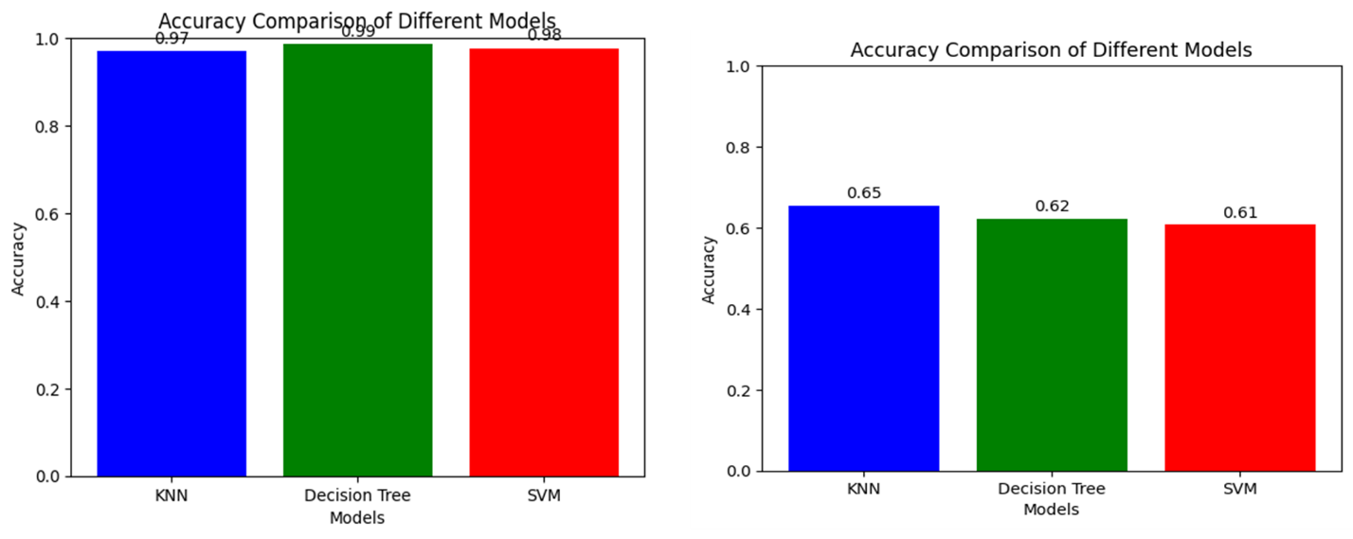

*Figure 4.18**: Accuracy of Models using NPK with other factors x Accuracy of Models using NPK solely*

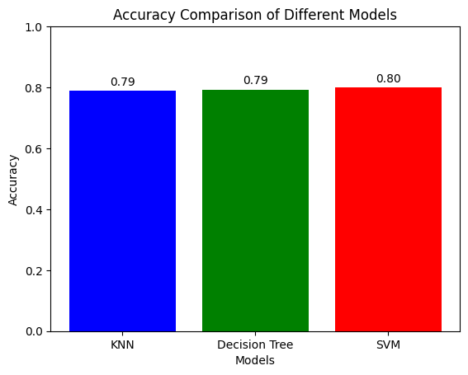

Figure 4.19: Accuracy of Normalized NPK dataset

4.7 **Website of the Proposed Model**

4.7.1 Home Page

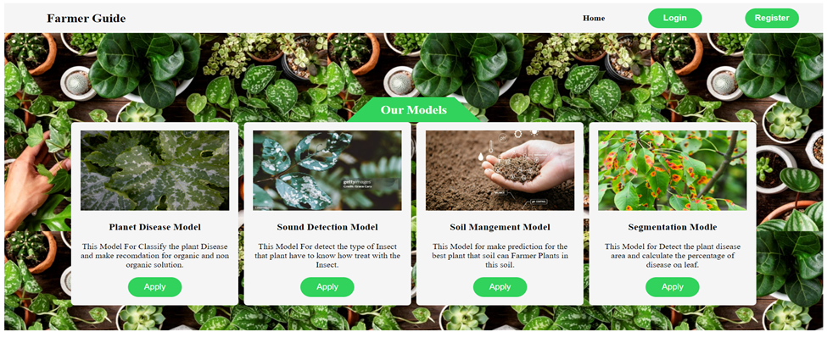4.7.1.1 Overview

Figure 4.20: Home Page

The Home Page of the "Farmer Guide" web application serves as the gateway to our various models designed to assist farmers in managing their crops more effectively. This page features a user-friendly interface with an inviting design, showcasing lush greenery to emphasize the agricultural focus.

4.7.1.2 Features

1. Navigation Bar

* Home: Redirects to the homepage.
* Login: Directs users to the login page.
* Register: Guides new users to create an account.

1. Our Models Section
   * Plant Disease Model
     + Description: This model classifies plant diseases and provides recommendations for organic and non-organic solutions.
   * Sound Detection Model
     + Description: This model detects the type of insect affecting the plant, helping farmers understand how to treat the insect.
   * Soil Management Model
     + Description: This model predicts the best plants that can be cultivated in a particular soil, assisting farmers in making informed planting decisions.
   * Segmentation Model
     + Description: This model detects diseased areas on plants and calculates the percentage of disease on the leaves.

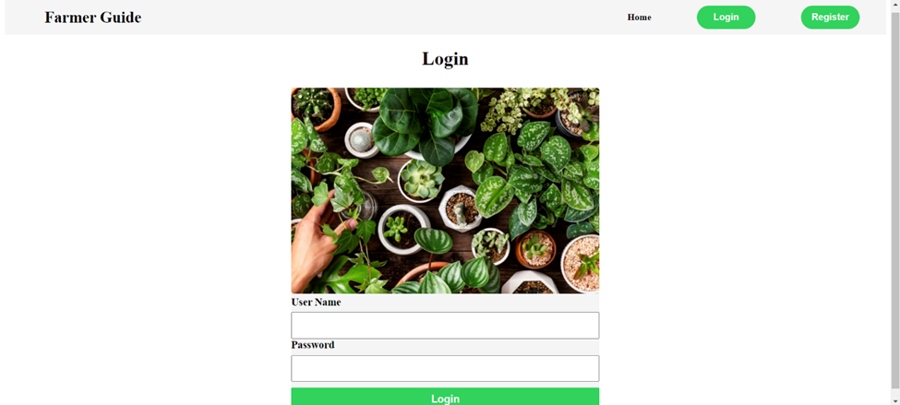 4.7.2 Login Page

Figure 4.21: Login Page

4.7.2.1 Overview

The Login Page of the "Farmer Guide" web application allows users to access their accounts to utilize the various services offered. This page ensures secure access by requiring users to enter their credentials before proceeding.

4.7.2.2 Features

1. Navigation Bar
   * Home: Redirects to the homepage.
   * Register: Guides new users to create an account.
2. Login Form
   * Username Field:
     + Allows users to enter their registered username.
   * Password Field:
     + Allows users to enter their password securely.
   * Login Button:
     + Submits the entered credentials for authentication.

4.7.2.3 Visual Design

The login page maintains a consistent visual theme with the rest of the application, featuring a vibrant image of various plants to create an engaging and welcoming environment. The form elements are designed to be simple and user-friendly, ensuring a smooth login experience.

4.7.2.4 Usage

To access any of the services provided by the "Farmer Guide" application, users must first log in through this page. Once authenticated, users can navigate to the desired model or service to manage their agricultural needs.

4.7.3 Registration Page

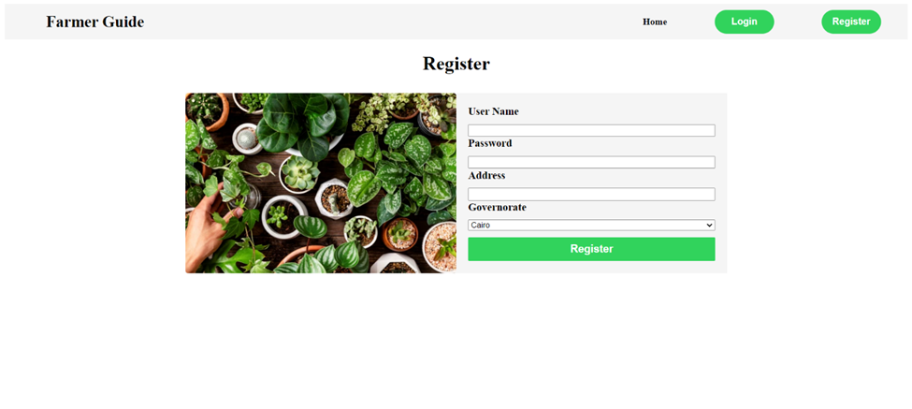4.7.3.1 Overview

Figure 4.22: Registration Page

The Registration Page of the "Farmer Guide" web application allows new users to create an account. This page is essential for users who do not have an existing account, enabling them to register and gain access to the various services offered by the application. It caters to two types of users: normal users seeking access to the website's services and admin users who are agriculture engineers.

4.7.3.2 Features

1. Navigation Bar
2. Registration Form
   * Username Field:
     + Allows users to enter their desired username.
   * Password Field:
     + Allows users to enter a secure password.
   * Address Field:
     + Allows users to enter their address.
   * Governorate Dropdown:
     + Allows users to select their governorate from a dropdown menu.
   * Register Button:
     + Submits the entered information to create a new account.

4.7.3.3 Visual Design

The registration page maintains the consistent visual theme of the application, featuring a vibrant image of various plants to create an engaging and inviting environment. The form is designed to be straightforward and user-friendly, ensuring a seamless registration process.

4.7.3.4 Usage

Users who do not have an account can register through this page by providing the required information. Normal users can access the website's services, while admin users (agriculture engineers) gain additional privileges tailored to their role, such as managing content or providing expert advice.

4.4 Normal User perspective

Normal users of the 'Farmer Guide' web application have access to a curated selection of essential services designed to enhance their agricultural experience. They can explore comprehensive resources tailored to farming practices, access their personal accounts to manage profile information, and seamlessly navigate through their order history. Additionally, users can leverage tools for placing orders, receiving updates on agricultural trends, and engaging with expert insights. This platform empowers users with the necessary tools to 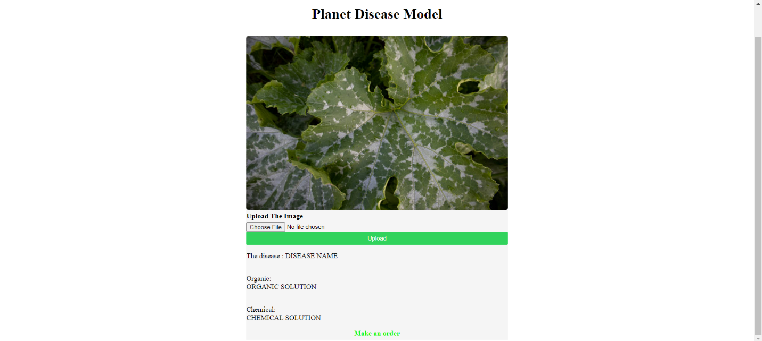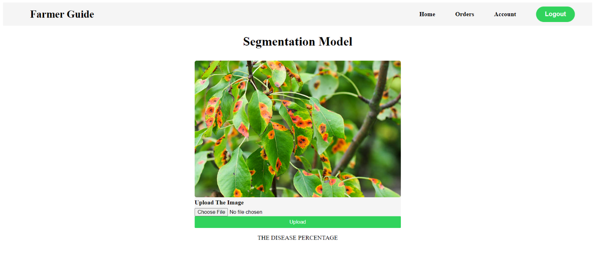optimize their farming practices efficiently.

Figure 4.24: Service2: Plant Segmentation

Figure 4.23: Service1 : Plant Disease Detection

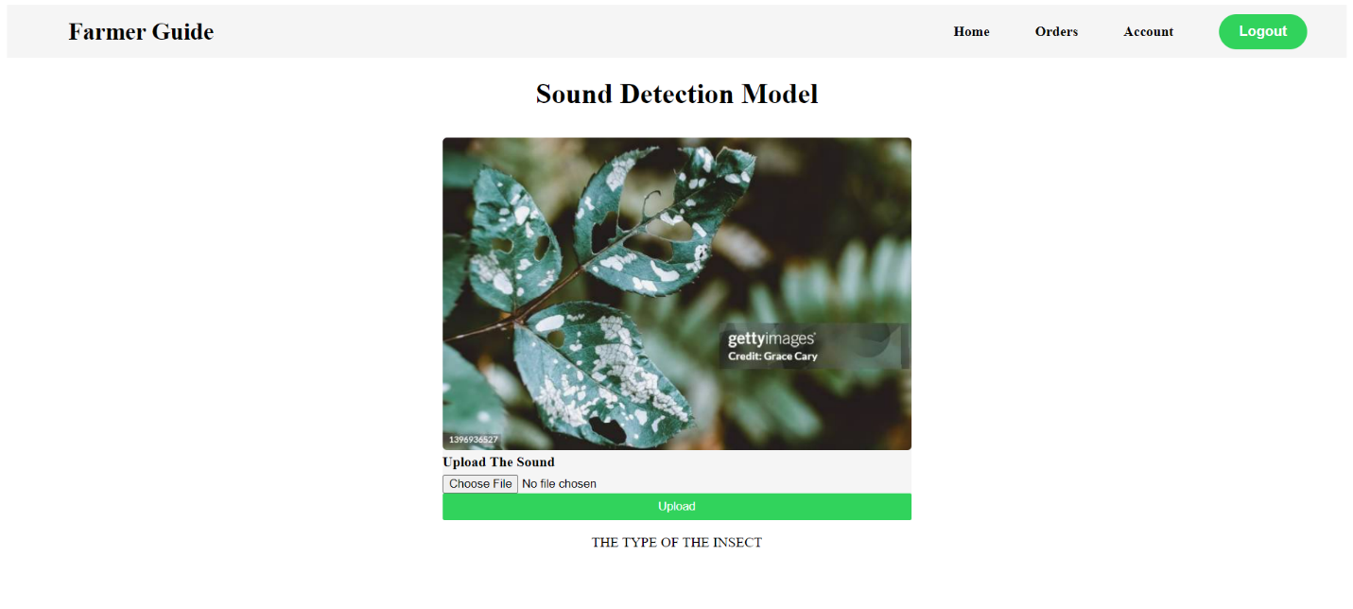

Figure 4.25: Service3: Insect Sound Recognition

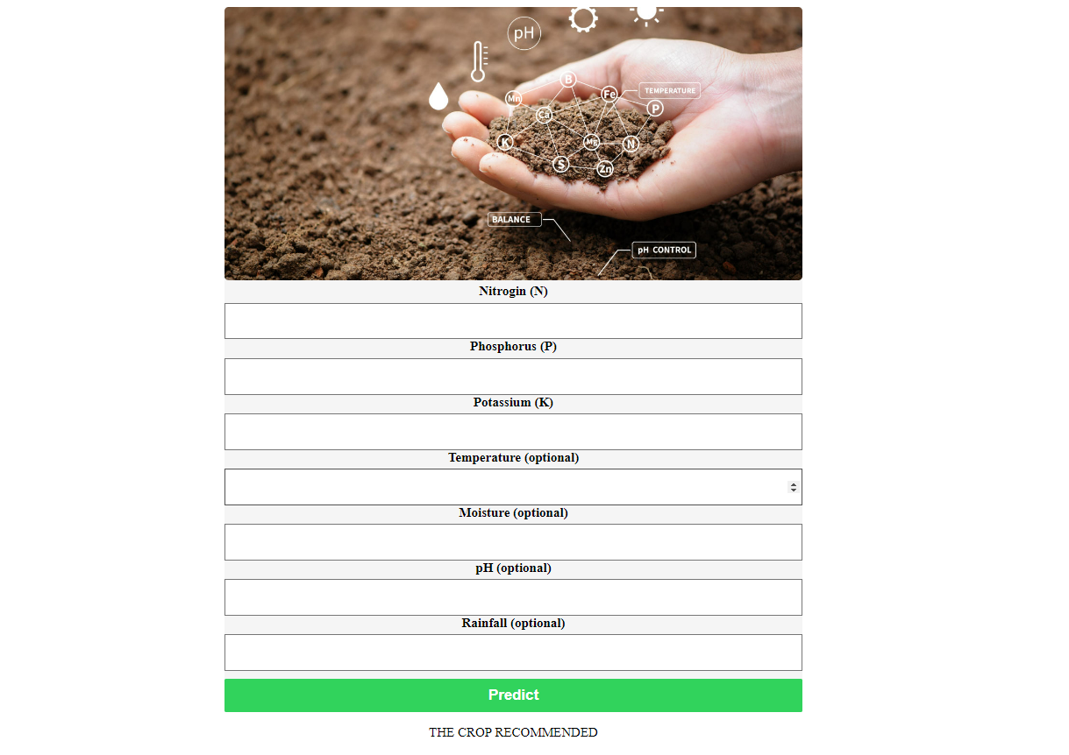

Figure 4.26: Service4: Soil Management and Crop Recommendation

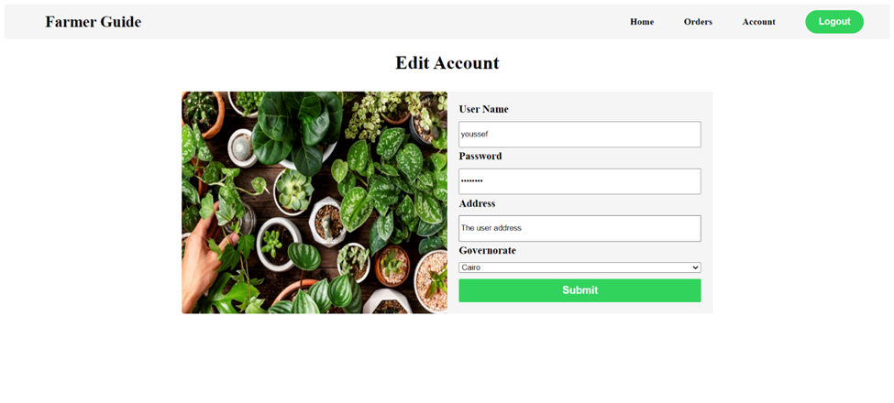

Figure 4.27: Edit Account

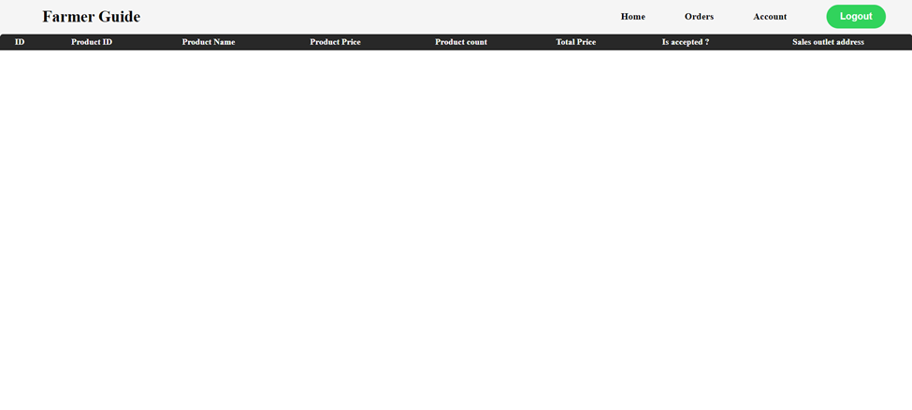

Figure 4.28: Show my Orders(table of the orders that the user made)

4.5 The Admin Users

The admin users of the 'Farmer Guide' web application possess exclusive access to three pivotal pages designed to streamline administrative tasks and optimize operational efficiency. Upon logging in, admins are redirected to the 'Show Incoming Orders' page, where they can meticulously review incoming orders. Here, admins hold the authority to accept or reject orders; upon rejection, orders are promptly removed from the database, while accepted orders are seamlessly transitioned to the 'Accepted Orders' page. This dedicated page highlights the admin's name associated with each accepted order, ensuring transparency and accountability. Furthermore, admins can utilize the 'Show Inventory' page to meticulously manage and monitor inventory levels, facilitating informed decision-making and streamlined inventory control 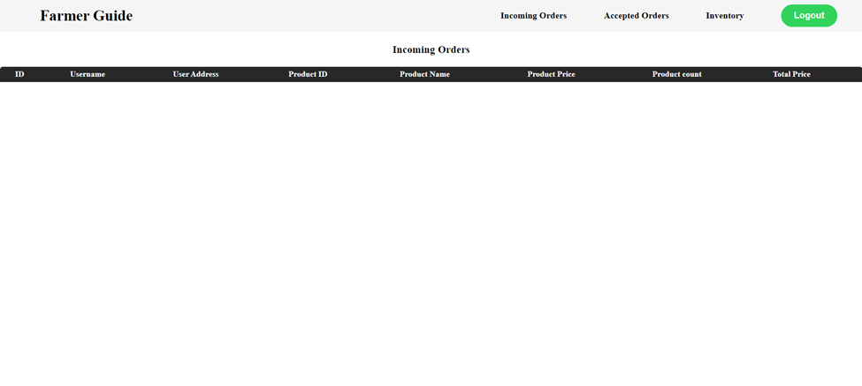processes.

Figure 4.29: Show Incoming Orders

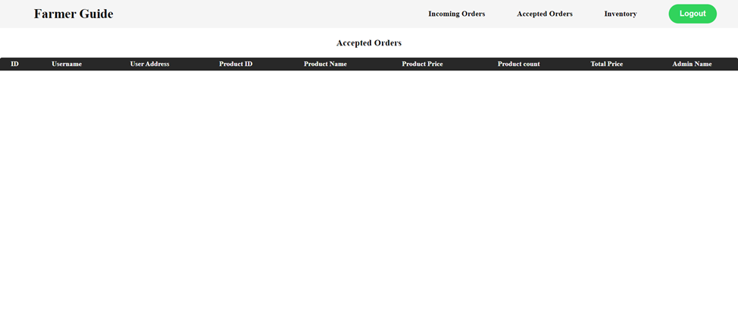

Figure 4.30: Show Accepted Orders

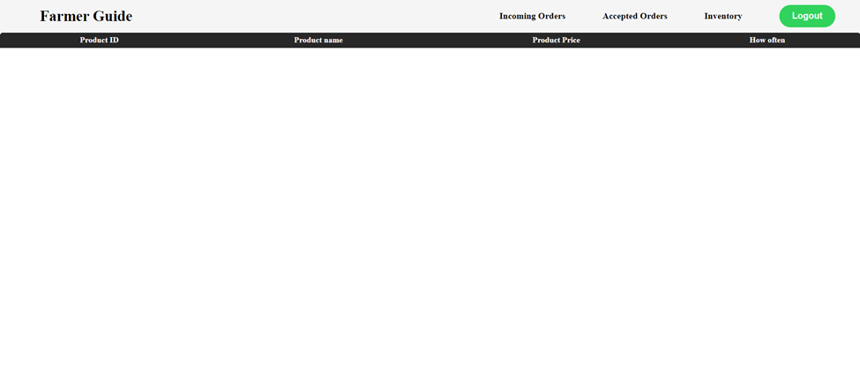

Figure 4.31: Show Inventory

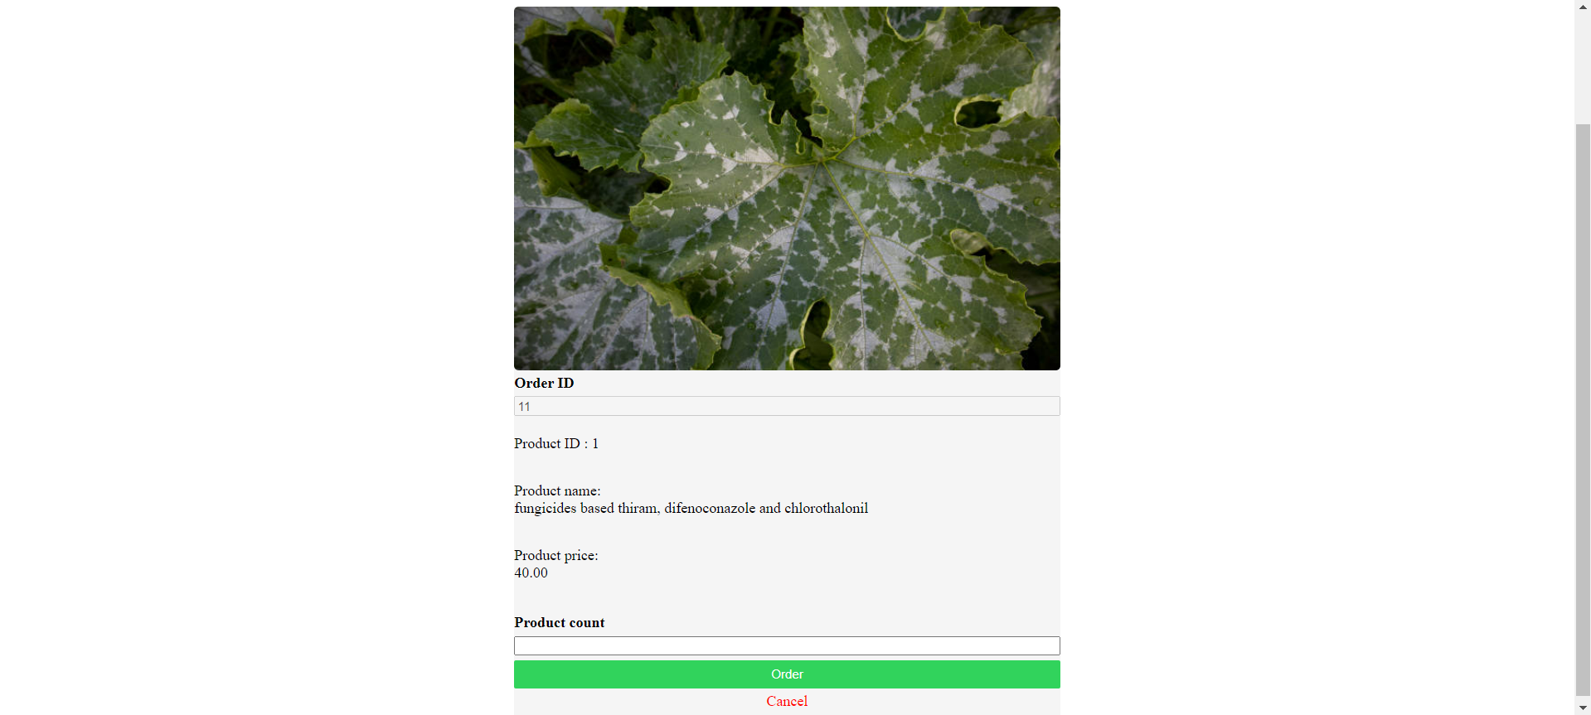

Figure 4.32: Send Order Page

**CHAPTER 5: Conclusion**

Our "Farmer Guide" project offers three essential services to farmers: crop protection through image detection of plant diseases, crop guarding via sound detection of insects around plants, and crop recommendation using sensors and machine learning. By leveraging these advanced technologies, our initiative provides farmers with comprehensive support to enhance crop health, minimize pest damage, and optimize crop choices based on soil conditions and environmental factors. Through the integration of image processing, sound analysis, and machine learning, our platform empowers farmers with actionable insights for proactive crop management, ultimately promoting agricultural sustainability and productivity.

The proposed system begins when the user/farmer signs up in the application and makes an official farmer account, or logs not the application if they already have an account, then they can use the services provided in the application. The services are made through the real-time connection between the application and the tools the farmer already has purchased and placed inside their farm/land. These tools are camera or phone-camera, mic, and sensor(s) depending on the farmer`s need/target of services. Now the farmer has made connection and ready to take input, the next step is processing depending on service in need, the application uses ResNet classification model for sound system, CNN model for image system, and we test the results of Support Vector Machine (SVM), Decision Tree (DT), or K-Nearest Neighbor (KNN) models for crop recommendation system.

The final accuracy of machine learning model used for each system.

For the sound system, before data augmentation, the accuracy was 93%. After exponential decay , the cumulative result of the training strategy yields a robust model with a final accuracy of 95%. This accuracy reflects the model's capability to accurately identify and classify various bugs sounds based on Mel Spectrograms.[8][9]

For the image system,

**Plant Diseases Detection on Common and Real Plant Disease Images**

A deep learning model using MobileNetV2 and transfer learning, combined with data augmentation, to classify plant health and various diseases. The model achieves an accuracy of 98.12% on common diseases with CNN and this accuracy didn`t get any higher after using transfer learning with MobileNet V2 on train or test dataset, and 97.5% on train dataset and 87.5% on test dataset, for real plant disease images after applying augmentation.

**Plant Diseases Segmentation**

Utilizes image segmentation techniques, including background removal, contrast enhancement, and contour extraction, to accurately identify diseased areas in plant images.

**Plant Diseased Area Percentage**

Calculates the percentage of diseased areas by summing contour areas and comparing them to the total leaf area, providing precise data to inform fertilizer application strategies.

For the crop recommendation system, when using the machine learning models on the whole dataset, DT was the best and gave 98.63% and when using NPK dataset solely, KNN was the best and gave 65.45%, and after applying normalization and augmentation , training the augmented data gave an accuracy of 79.90% using SVM.

**REFERENCES**

[1] <https://www.kaggle.com/datasets/vipoooool/new-plant-diseases-dataset>

[2] S.C. Madiwalar and M. V. Wyawahare, "Plant disease identification: A comparative study," 2017 International Conference on Data Management, Analytics, and Innovation (ICDMAI), 2017, pp. 13-18, doi: 10.1109/ICDMAI.2017.8073478.

[3] G. Shrestha, Deepsikha, M. Das and N. Dey, "Plant Disease Detection Using CNN," 2020 IEEE Applied Signal Processing Conference (ASPCON), 2020, pp. 109-113, doi: 10.1109/ASPCON49795.2020.9276722.

[4] <https://www.sciencedirect.com/science/article/pii/S2214317316300154#bb0010>

[5]<https://agdatacommons.nal.usda.gov/articles/dataset/Bug_Bytes_sound_library_stored_product_insect_pest_sounds/24664824>

[6] <https://www.thoughtco.com/exponential-decay-definition-2312215#:~:text=In%20mathematics%2C%20exponential%20decay%20describes,of%20time%20that%20has%20passed>

[7] <https://en.wikipedia.org/wiki/Exponential_decay>

[8] <https://www.cuemath.com/exponential-decay-formula/>

[9] <https://www.khanacademy.org/math/algebra/x2f8bb11595b61c86:exponential-growth-decay/x2f8bb11595b61c86:exponential-vs-linear-models/a/exponential-growth-decay-faq>

[10] <https://keras.io/api/applications/inceptionv3/>

[11] <https://paperswithcode.com/method/inception-v3>

[12] <https://keras.io/api/applications/mobilenet/>

[13] <https://www.tensorflow.org/api_docs/python/tf/keras/applications/MobileNet>

[14] <https://www.kaggle.com/datasets/atharvaingle/crop-recommendation-dataset>

[15] <https://scikit-learn.org/stable/modules/tree.html>